**Final Project Report**

|  |  |  |
| --- | --- | --- |
| **Selected Topic** | **Topic 4** | |
| **Group Membership** | **Student ID** | **Name** |
| **Member 1** | **18436617** | **WANG Guoquan** |

1. **Introduction**

This project is a clinical decision support system.

It faces to high level users like doctors and nurses. This system is not suitable for normal patient use because it directly gives the death rate of current patient. Patients may experience unpredictable mental setbacks. Normally, doctors use this system to calculate the mortality rate one year later, communicate with patients' families through reasonable and effective methods and give effective advice.

1. **Problem Formulation**

Topic 4 involves implementation

It need to search, admin, show detail of patient record, show the history of patient.

Sails.js is a Node.js Model-View-Controller (MVC) framework. It is easy to develop the basic CRUD (Create, Retrieve, Update, Delete) operations, as well as some other more advanced ones.

Basically, project will be designing based on sails.js. collaborations may with other group with topic 3 or 2.

Sails is a popular computer language with MVC framework

Bootstrap is a quick solution for making front-end

Processing data with WEKA tools

Currently, my project does have a rudiment on GitHub. There are several functions already achieve, for example, index, search, paginate, create, delete.

Public GitHub link:

<https://github.com/FatherW/clinicalDecisionSupportSystem.git>

1. **Method**

There are amount of page of my project.

**Index page**

In the figure 1, index page, it use bootstrap to build up a navigation bar, a jumbotron. And some card on the bottom.

The link inside the card can link the page to detail, which is a page listing an entire page of patient. By using a *<% persons.forEach( function(model) { }%>*loop to display each property of the patient. The link can use a href like *<a href="person/detail/<%= model.id %>" class="card-link">link to detail</a>*to redirect.

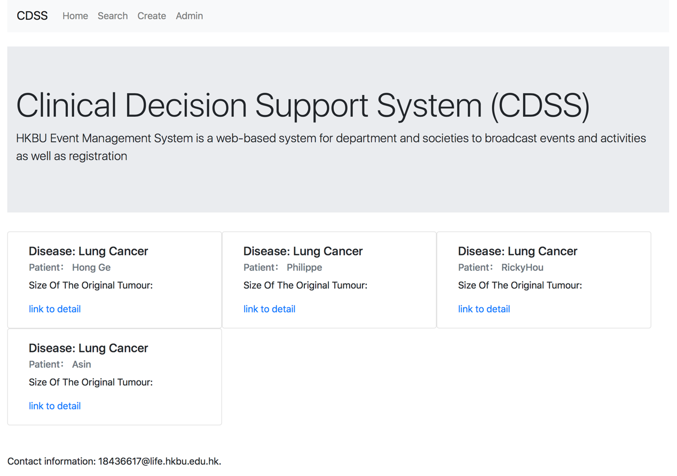

Figure 1: Index page

**Detail page**

In the figure 2, insert an inside the card can display the property of patient like name, age, Asthma, PAD, the size of tumour, which is a page listing an entire page of patient. These are uses in the *<li class="list-group-item">Age:<%= person.age %> </li>*. So, if we want to add some other function in the detail page. Just need to declare in the api model and show the dynamic interface on the detail page and the system can deal with it.

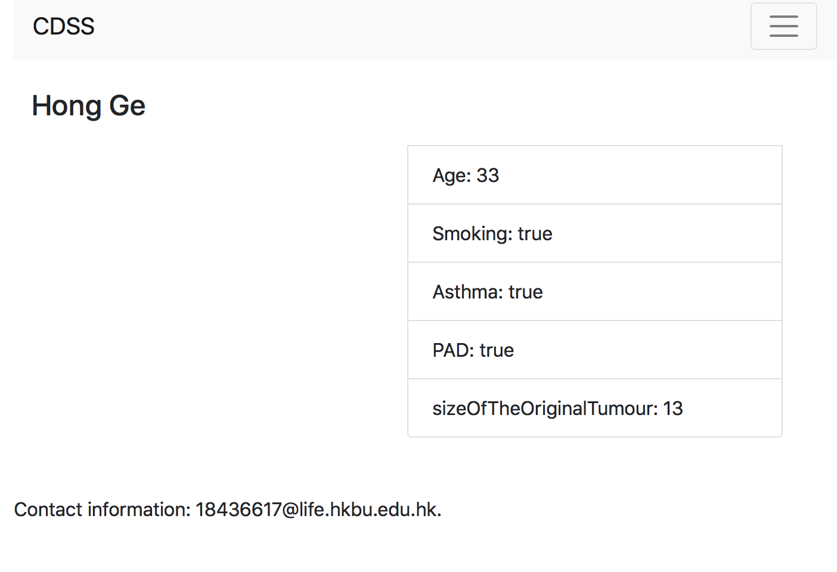

Figure 2: Details page

**Admin page**

Admin page has a function about delete the person from the database. While we setup a delete controller as well. Inside the delete controller. We use a fetch like here *var models = await Person.destroy(req.params.id).fetch();* this fetch has a function to delete api from database. Then set up the route.js both GET and POST. So we can directly use a href to delete patient *<a href="/person/delete/<%= model.id %>" class="btn btn-danger">delete</a>.*

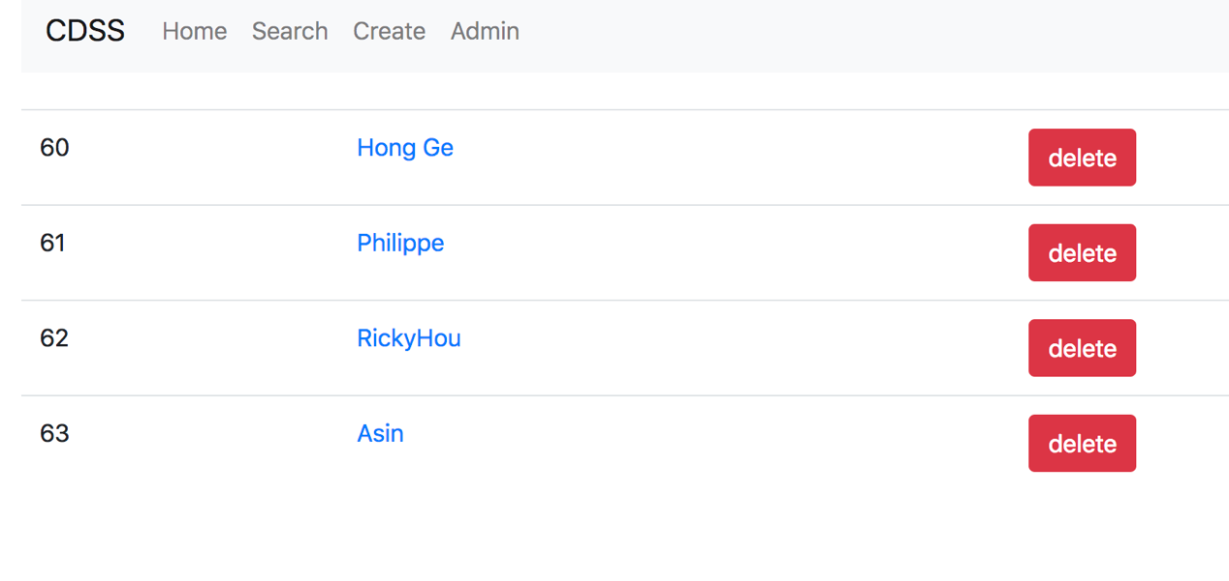

Figure: Admin page with delete function

**Search page**

This search page in my project has two different function. One is search, another is paginating. The paginate is use to display only 2 patients in the body. Once the patient number become large, without the paginate the page return super slow. Also, it can search for Boolean value.

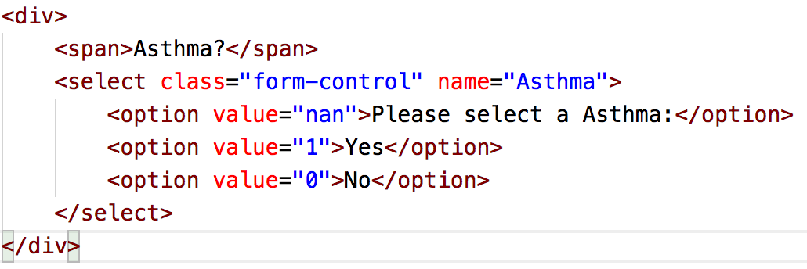

Figure: Search for Boolean value

Thus, the system has multiple searching way to deal with the patient.

For future work, it can simply add any model on the model and add the property in the search page.

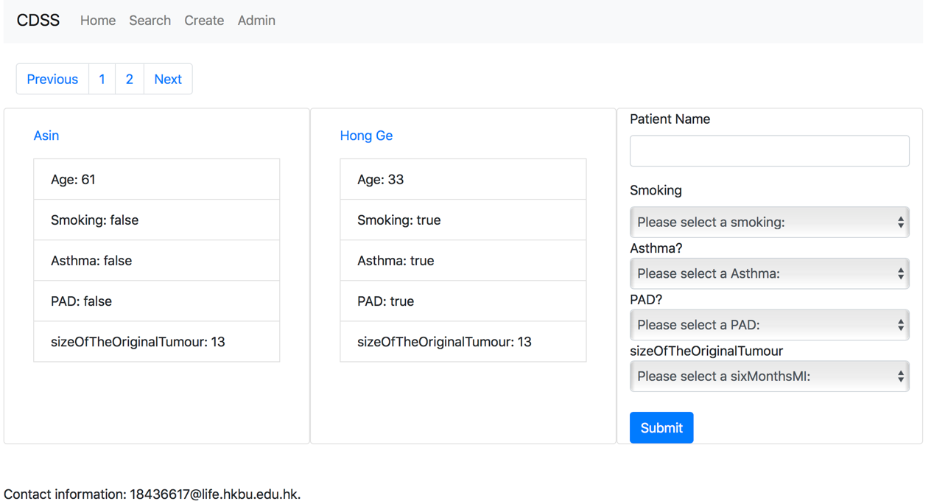

Figure 4: Search page

**Update page**

The logic of update page is a little same as create page. It get the value from the database and show the value on the input area. Also, it can deal with Boolean value.

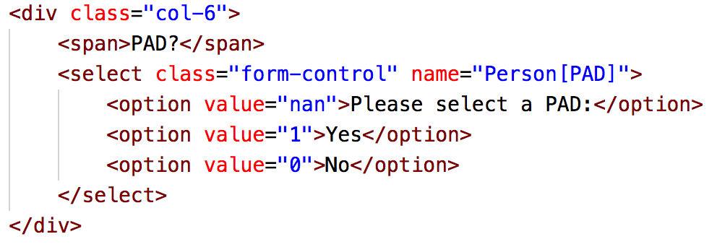

Figure: Update page deal with Boolean value

**Create page**

Create page is the most important part of my entire project. It not only give a sample create function, but also give a superb algorithm to calculate the risk of one year die.

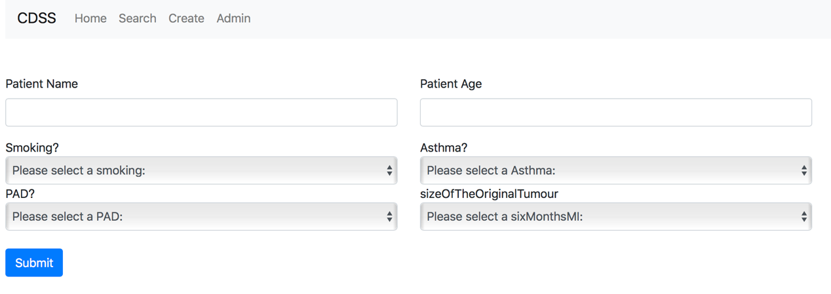

Figure: Create page

It can get the value from the patient and calculate the risk. This can help patients and their family members to better understand their condition, obtain effective doctor-patient communication, promote family harmony, and make different treatment/abandonment choices as soon as possible. Some patients choose to return home for financial or other reasons. There is an old saying in China that leaves fall to their roots. They are unwilling to make themselves the burden of their families.

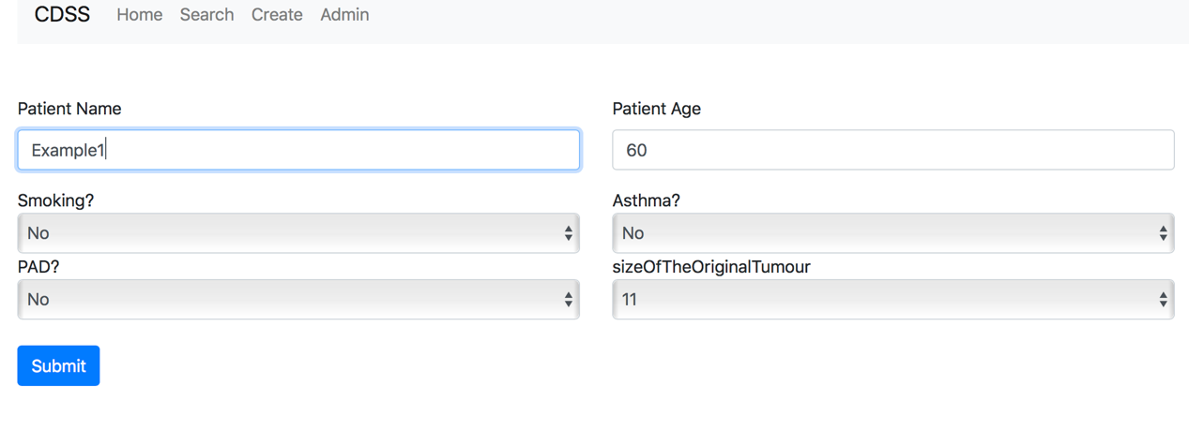

Figure: An example input

Once the create has done, system will return a sentence about die.

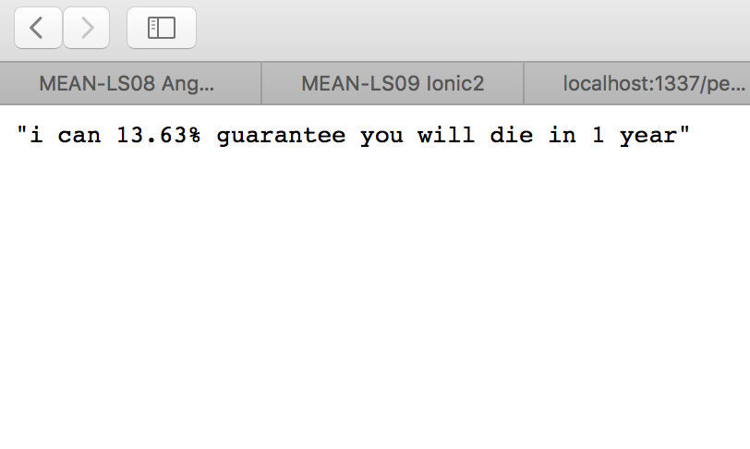

Figure: An example output

According to the data we have, the one-year mortality rate after the onset of lung cancer is not particularly high. 70 of 470 people died. The mortality rate is 14.89%. Because the patient in the example suffers from a variety of other diseases at the same time. And there less different degrees of bad habits. So the results are lower than the average.

1. **Data Description**

In this project, the potentially influential risk factor(s) of lung cancer from a UCI dataset: the Thoracic Surgery Dataset: https://archive.ics.uci.edu/ml/datasets/Thoracic+Surgery+Data

Figure: Attribute Info

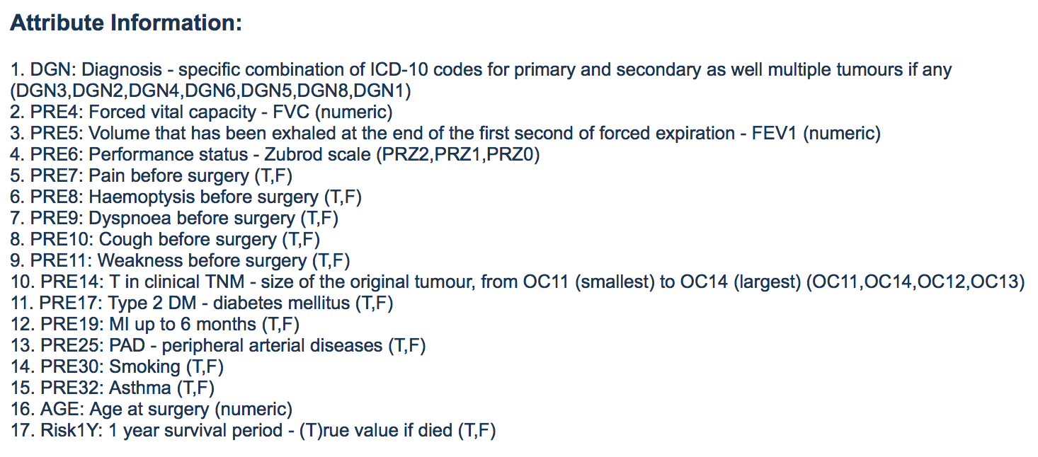

So, we have Risk1Y as dependent variable. Another 16 different independent variables. According to this information, we can do a regression on the dataset.

We use WEKA as our project software to do the regression.

Figure: dataset with SMO algorithm

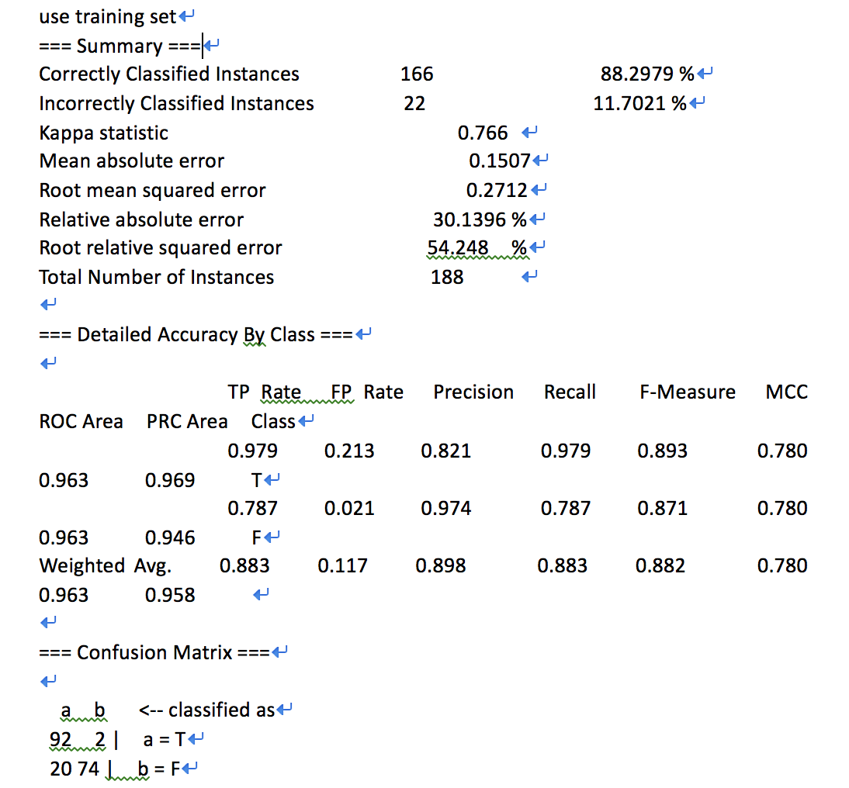

Figure: neural network result of WEKA

Firstly, we deal with the data set as neural network. Weka gives us result below.

Correctly Classified Instances data has 166 set and the rate is 88.2979 %. This value shows the dataset is Trustworthy.

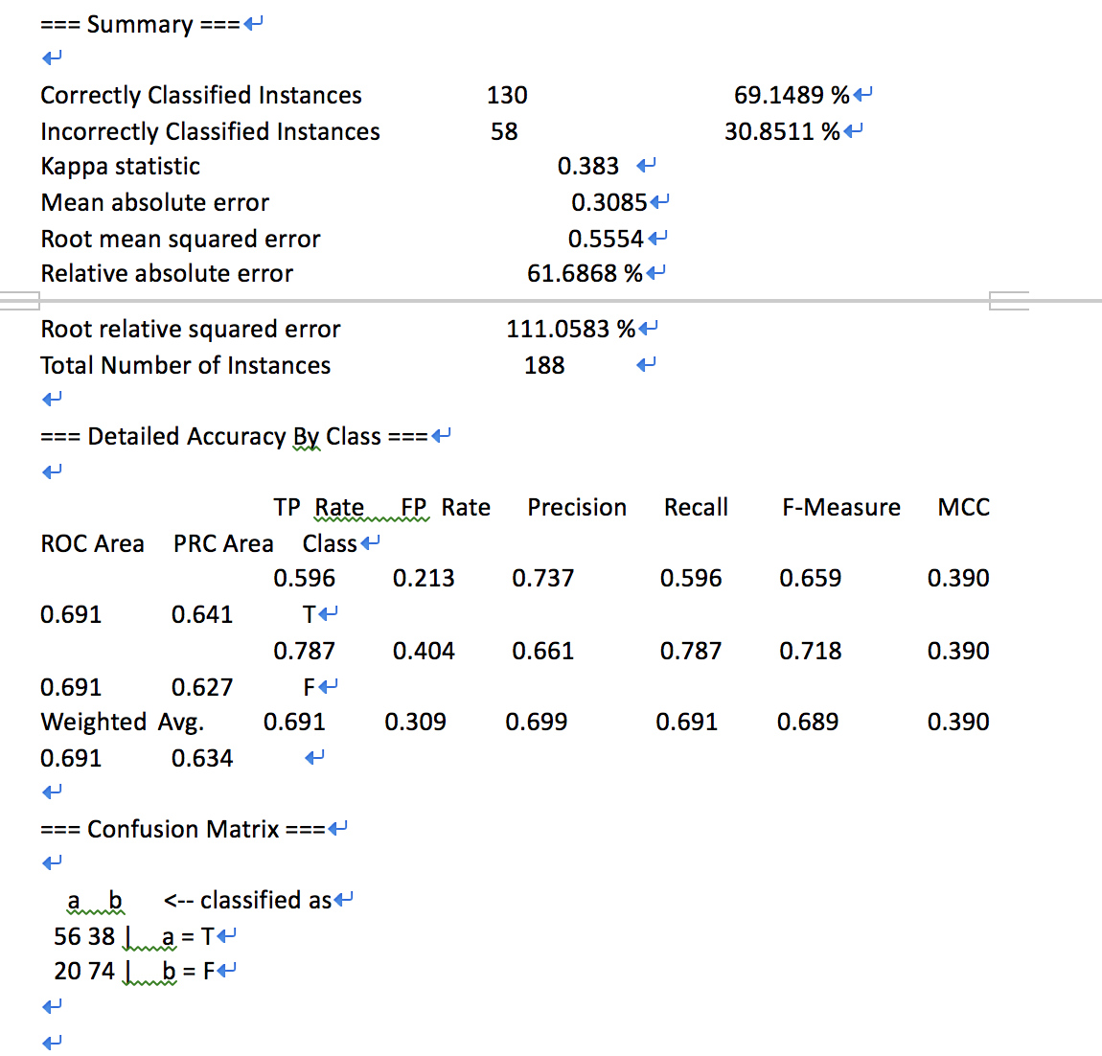

Secondly, we push all the dataset to SMO algorithm. We can see the precision is 0.737, 0.661, 0.669, which shows the data is particularly reliable.

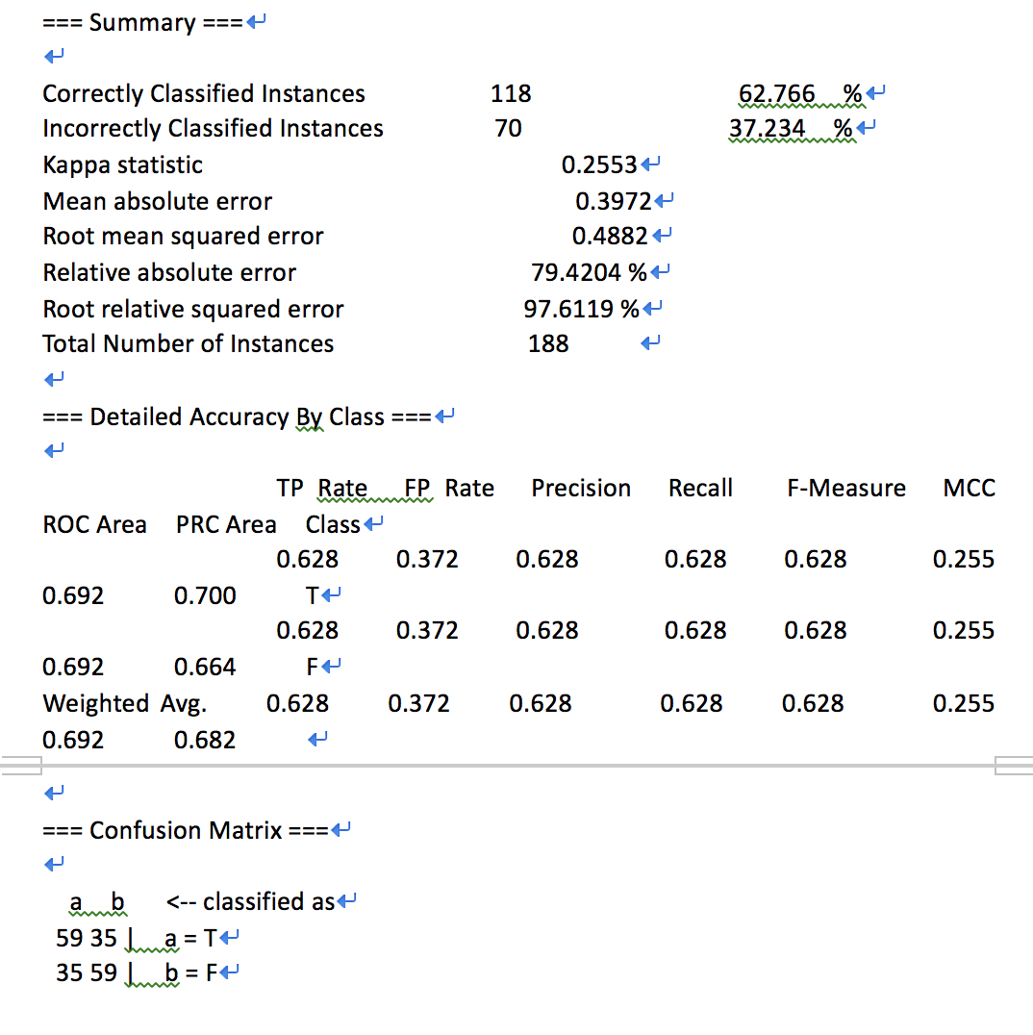

Figure: Knn-IBK result

Thirdly, we deal with the data by Knn-IBK. It is hard to find the K value to fit the algorithm. We set K=10 to calculate. The result of Knn-IBK is above.

We can see an overall value by WEKA

This make patient more intuitive understanding of their illness (lung cancer)

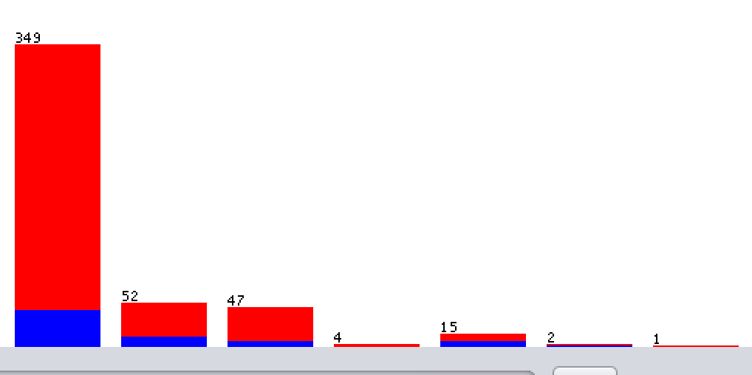

Figure: overall value from training set

Several different algorithms are used to synthesize the four results. The most important algorithm is **InfoGainAttributeEval**

With the help of WEKA, the reliability of these variables can be easily calculated. After calculate, these 4 independent variables are the most reliable.

The results obtained by using these four independent variables are the most representative.

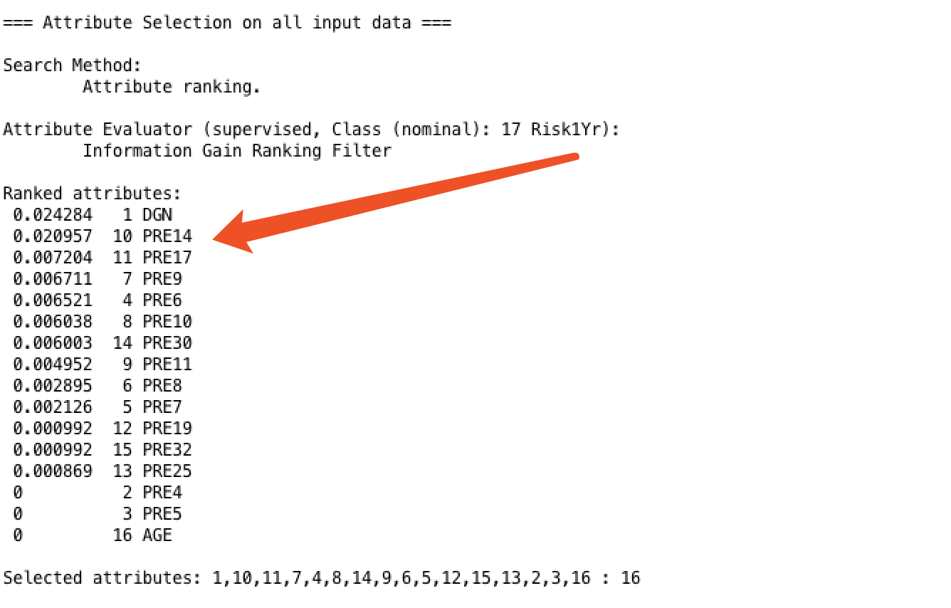

This algorithm directly shows the important list of independent variable in all the 16 variables. According to this result, we can draw a conclusion about which 4 variable I need to use. Although I can set all the variable to the system. In that case, my system will become extremely complex. Each additional patient takes a long time to add. This is an extra expense. I want to minimize variables as much as possible while ensuring accuracy. Make the whole software run more concise and easy.

That is also the reason why I only pick 4 variable in my create page.

1. **Results**

The result of my system is sample. Firstly, we can deal with the condition as the worst patient. For example, when the patient developed lung cancer, he suffered from all different complications and had all kinds of bad habits. And he has the biggest size of tumour.

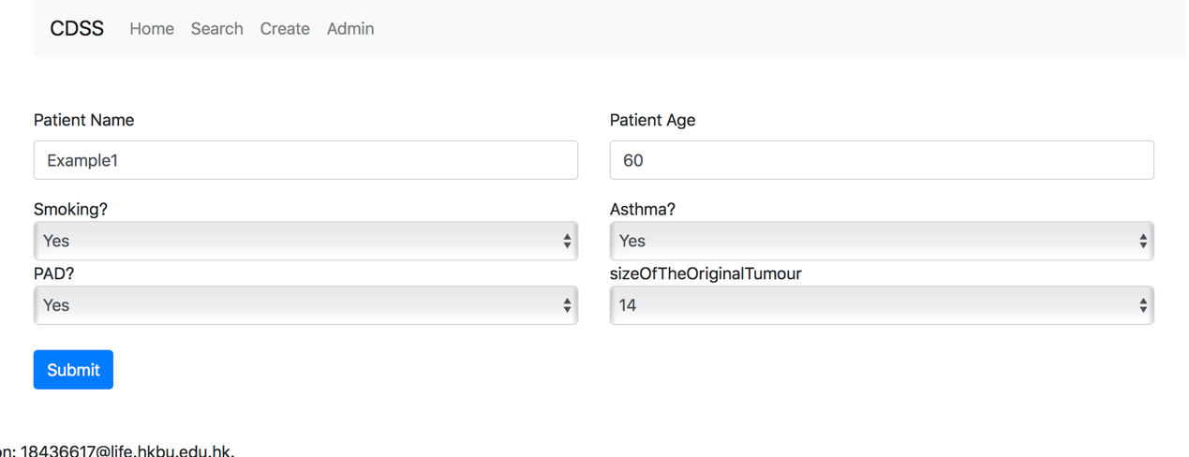

clicking on submit, system return the result

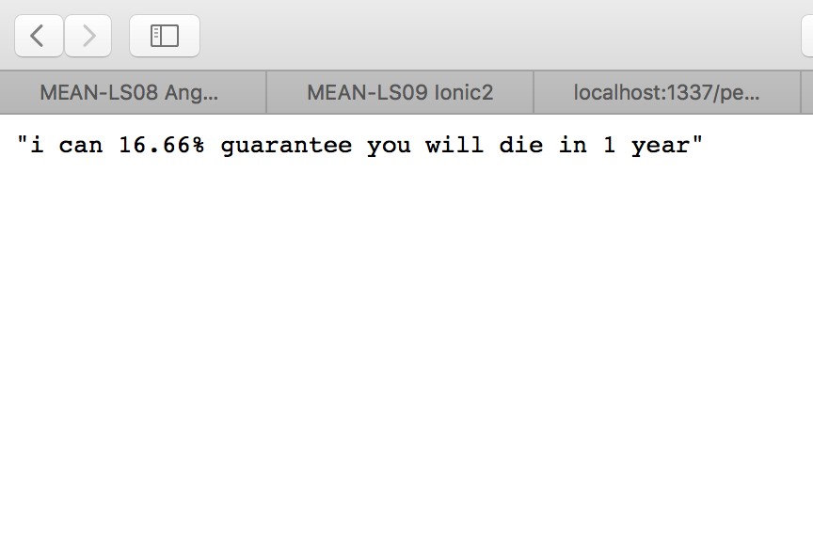

Figure: worst condition result

For another patient, this patient has no bad habits in life, does not stay up late, does not drink, does not smoke. No complications associated with lung cancer. We still need to check this patient

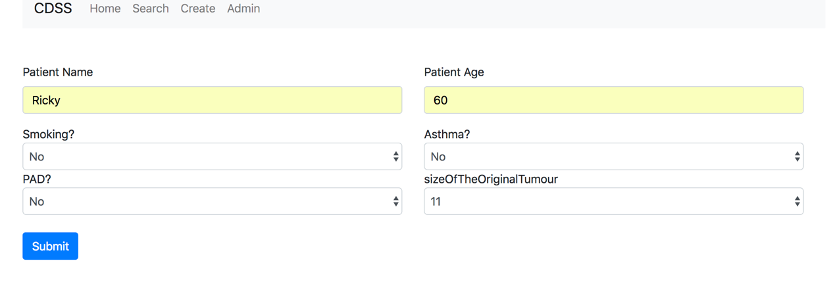clicking on submit, system return the result

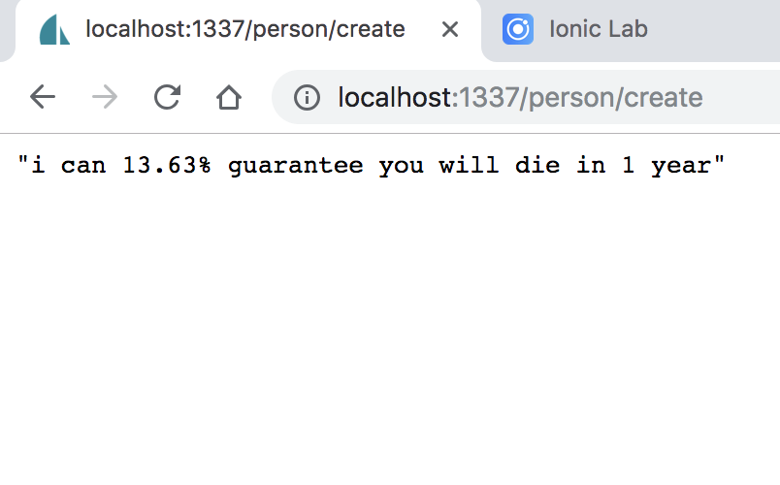

Figure: best condition result

From this we can draw a conclusion. Bad habits in our daily life are the key factors that directly affect our life and health. In lung cancer, the one-year mortality rate of having bad habits is more than 3% than that of not having bad habits. This is a warning to young people not to stay up late at night, not to drink and not to smoke.

1. **Future Work**

The calculation of death rate is use the current death rate to multiply the rate of bad habit like smoking. Unfortunately, these numbers are static.

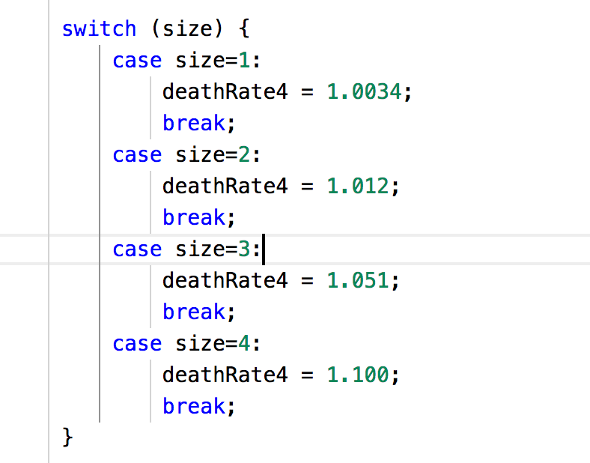

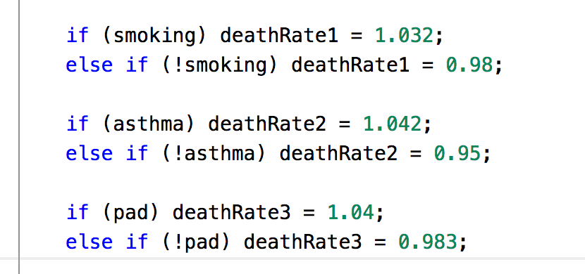

Figure: calculation about smoking asthma PAD

If the statistics are not accurate enough, the results may not be particularly referential.

Unfortunately, in future continuous statistics, there will not only be 470 patients, but more and more patients will be included in our statistics. Normally, the system needs to be continuously updated every year. This is unacceptable in general hospitals.

Where this system can be further improved, as other teams have already implemented, it can differentiate different users by categorization. Patient is not allowed to visit the creation page, so that they can access the information of historical patients, can obtain very effective reference significance.

Clinicians interact with a CDSS to help to analyze, and reach a diagnosis based on patient data.

1. **Author Contributions**

WANG Guoquan carry out the entire project.

1. **References**

**[1] Ragsdale C T. Spreadsheet Modeling & Decision Analysis[M]. Cincinnati, OH, USA: Thomson Nelson, 2006.**